**Phone Book**

Time limit: 3.5 hours

The backend server provided to you maintains the list of contacts and provides a REST API for fetching, creating, updating and deleting contacts. A contact consists of a name and a (single) phone number.

**First, start the backend**

Install the packages in the backend first, and start it. The API endpoint is <http://localhost:4000/contacts> and it supports GET, POST, PUT, DELETE methods for CRUD operations.

**Next, build the Angular frontend app**

Create the Angular app to build a phone book, that lets the user manage a list of contacts, and serves as a frontend for the supplied backend application.

**Feature 1: List contacts**

When the app first loads, it shows the following form to add a contact

(texts shown in inputs are placeholders). This is rendered by an **AddContact** component. Additionally, the initial set of contacts are fetched from the backend and shown. The list is rendered by a **ContactsList** component, the individual contact by **ContactListItem**.

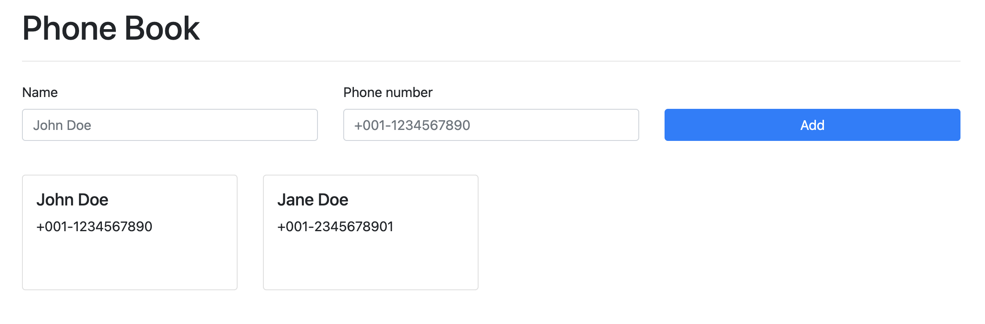

**Feature 2: Add contact**

When the user enters contact details (name and phone number), and clicks the Add button, the contact is added. After a few contacts have been added it looks like this.

**Feature 3, 4: Edit contact, Delete contact (buttons)**

When hovering over contact (say, Jane Doe), the **Edit** and **Delete** buttons appear (if that is not possible, you may make these appear on everycard even when not hovering).

**Feature 3: Edit contact**

|  |  |
| --- | --- |
|   **Figure 4 (Edit contact)**: Clicking the Edit button, opens up a form inside the clicked card, with details of the contact populated in the inputs. |   **Figure 5 (Edit contact)**: Clicking **Save** updates the contact and shows the lists of contacts again (here Jane Doe has been updated to Janette Doe) |

**Hint for Editing feature**: Maintain an **isEditing** boolean variable in the ContactListItem component. Set its value to true when the Edit button is clicked. Conditionally render either the contact details, or the form based on the isEditing variable’s value. Send the edited name, phone number using an @Output event to ContactList when the Save button is clicked.

**Feature 4: Delete contact**

|  |  |
| --- | --- |
|   **Figure 6.1 (Delete contact)**: Clicking the **Delete** button deletes the contact (screenshot is from **before** deleting Mark Smith) |   **Figure 6.2 (Delete contact)**: Clicking the **Delete** button deletes the contact (screenshot is from **after** deleting Mark Smith) |